Sample Question Dataset
Notes:
A question requires 5 components: question header, question body, question answer, solution, and explanation (optional).
Try to avoid complicated styling. If you really wish to include that, converting into an image is suggested.
Use plain text for lists instead of the built-in list in MS Word.
The following will be a sample question dataset showing the required format of a database. You may play with this document and upload it to the “Add questions in batch” function to review the results.
1. 24-25 MATH0000 Q1
1 + 1 = ?
A. 0
B. 1
C. 2
D. 3
Solution: C
One plus one is two

2.) 24-25 MATH0000 Q2
In the figure, $\mathit{PQRS}$ is a rectangle. Let $\mathit{T}$ be a point lying on $\mathit{QR}$ such that $\angle PTS = 90 \degree$. $\mathit{PQ}$ produced and $\mathit{ST}$ produced meet at the point $\mathit{U}$. $\mathit{PT}$ is produced to the point $\mathit{V}$ such that $RT = RV$. Which of the following must be true?
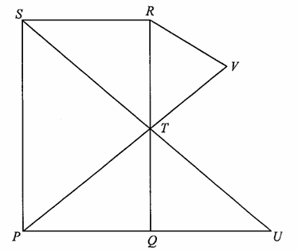
A. $RV // ST$
B. $\angle PTQ = \angle RTS$
C. $\triangle PST \sim \triangle UTQ$
D. $\triangle PQT \cong \triangle TRS$
Solution: C
$\angle PTS = \angle UQT = 90 \degree$
$\angle PST = \angle UTQ \; (corr. \; \angle s, \; PS // QT)$
$\triangle PST \sim \triangle UTQ \; (AA)$
(Question from HKDSE 2023 Maths Paper II Q21)
You can also include images and markdown (KaTeX here) in the question.

(3) 24-25 MATH0000 Q3
Consider the following statements about 5 Boolean variables A, B, C, D and E:
- If A is true then B is true.
- C is true if and only if B is true.
- If A and B are equal then D is true.
- If B and C are equal then E is true.
Which of the following statements is always correct?
A. If B is true then D is true.
B. C is true if and only if A is true.
C. At least one of B and D is true.
D. It is possible that exactly one of A, B, C, D, E is true.
Solution: C
Consider the contrapositive statement of statement 1: “If B is false then A is false.”
Then we can take one case of statement 3: “If A is false and B is false then D is true.”
Combining with the contrapositive statement of statement 1 we get: “If B is false then D is true”, which has the same meaning as “At least one of B and D is true.”
(Question from Hong Kong Olympiad in Informatics 2023/24 Heat Event Senior Group Q15)
It is suggested to use a bulleted list instead of a numbered list in the question body to avoid clashing with the question headers.

